Thread with Love
Lewis & Irene
Design and made by Sally Ablett
Size 10" (h) x 12" (w)

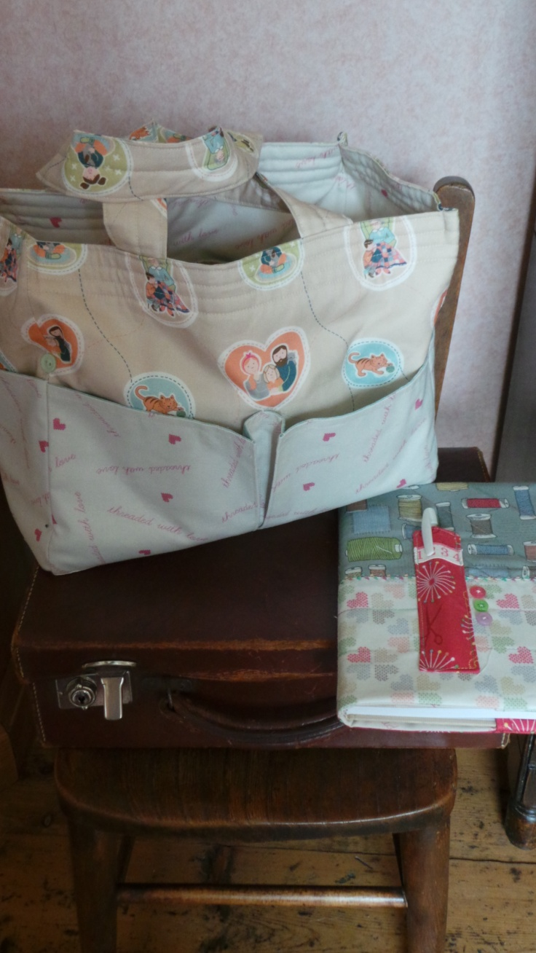
Requirements
- A180.1 – family on cream - ½yd - ½mtr
- A181.1 – pink threaded with love - ½yd - ½mtr
½mtr wadding
½mtr med/weight sew-in interfacing for stiffening pockets
½mtr of lining fabric for pockets
4 buttons

Cutting

From each of fabrics 1and 2 cut
2 x 10½" (h) x 12½"(w) for main section
2 x 3½" x 12½" for base
2 x 10½"(h) x 6½"(w) for sides
2 x 6½"(h) x 15½"(w) pockets
2 x 6½" x 6½" side pockets

From lining fabric cut
4 x 6½" x 15½"
4 x 6½" x 6½"

Handles cut
2 x 3" x 15" from whichever fabric you prefer

Wadding cut
2 x 13" x 12½" main section
2 x 6½" x 10" side panels
2 x 1" x 15" for handles

Interfacing - cut this slightly smaller than the main piece to reduce bulk in seam allowance
4 x 6" x 14½"
4 x 6" x 6"

Sewing

Use ¼" seam allowance throughout. Press seams as you go.

The following instructions are to be used together with the diagrams, please refer to them whenever necessary.

- Sew the pocket lining fabric to fabrics 1and 2 strips right sides together with the interfacing between the two layers, trim the interfacing, and turn to right side and top stitch the upper edge. Do this to all eight pockets.

- Fold an inverted centre pleat in the four large pockets so that they fit the width of the main backing pieces.

- Press and top stitch the pocket creases.

- Lay the backing piece onto the wadding (this will be slightly larger than the backing piece) leaving a ½" gap at the top to make turning in easier.

- Place the pocket onto the backing piece and stitch down the centre of the pleat to attach. Repeat for the other outside piece

- Sew one bottom strip to each panel.

- Side pocket; Lay the backing fabric onto the wadding (again there will be a ½" gap at the top for turning) and place the pocket on top keeping the lower edges even.

- Sew the side panel to the main panel stopping ¼" from the lower edge.

- Repeat with the other side panel and then sew the remaining side seams.

- Sew across the centre base seam, turn right side out again.

- Make the lining in the same way but without the wadding.

- Place the lining inside the bag wrong side’s together, turn in ½" all round and pin in place.

- Make the two handles, turn in ¼" down each long side and press, fold in half lengthways and place the wadding in the fold, top stitch down each side.

- Position the handles between the linings and the outer bag approximately 3" in from the side seams. Top stitch all round the bag

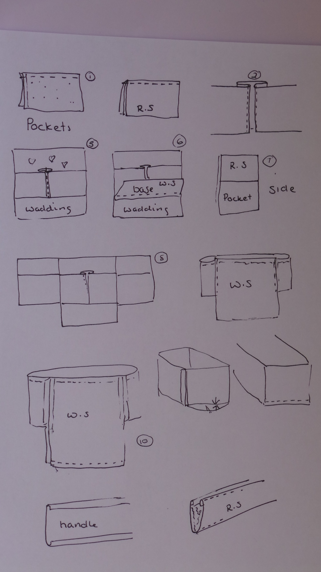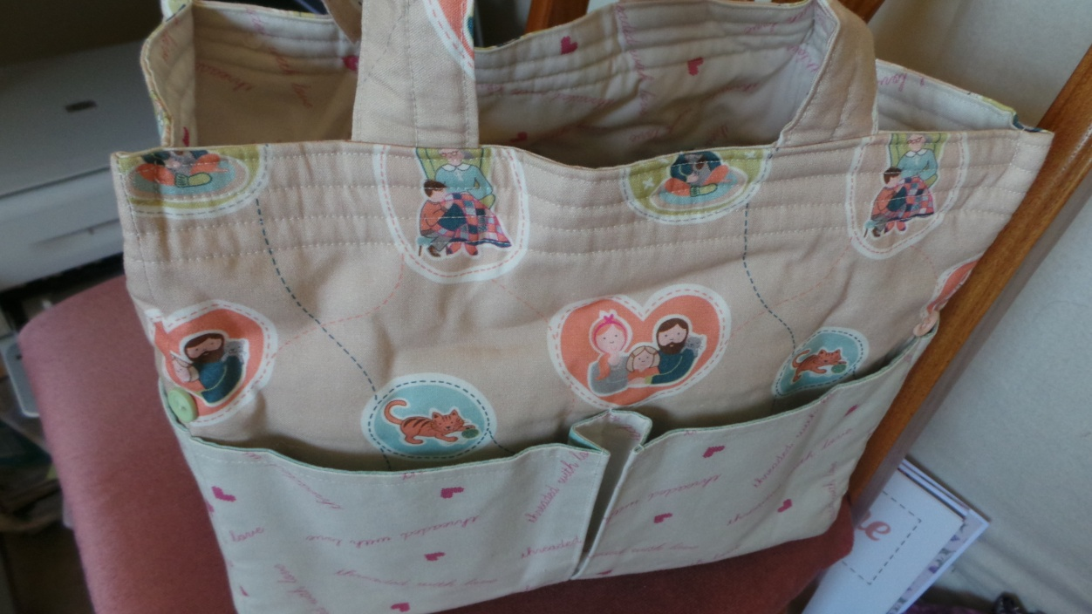

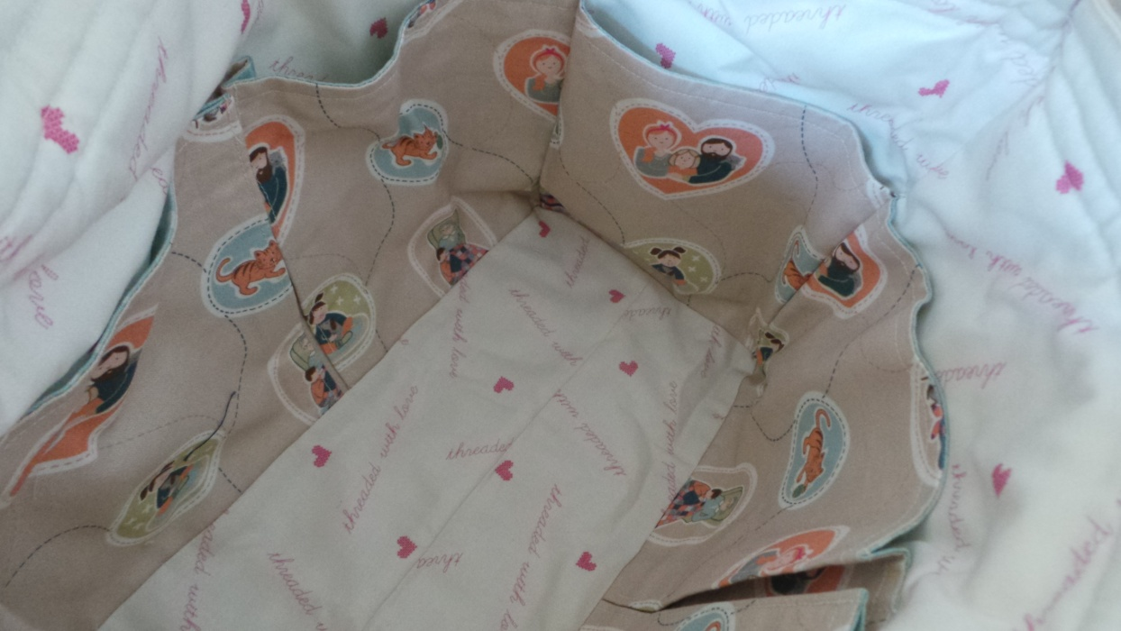

Note book made from a pattern on the internet

Sally Ablett ©

