Northern Lights runner 2
Lewis & Irene
Designed and made by Sally Ablett
Size 10" x 40"
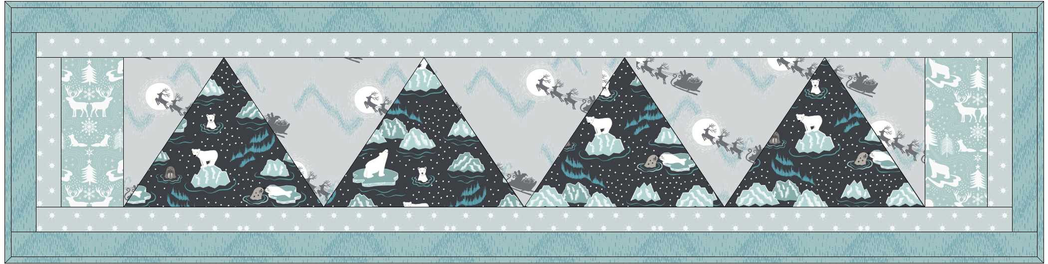
Main diagram
Requirements
Fabrics from the Northern Lights collection:
- C1.1 - Santa`s sleigh on silver – long ¼
- C2.2 - Northern lights on icy blue – ⅜yd – 40cm
- C3.3 - Walrus & friends on midnight – long ¼
- C4.2 - Star on silver – long ¼
- C5.3 - Arctic animals icy blue – long ¼
Wadding and backing 14" x 44"

Use ¼" seam allowance throughout. Press all seams open unless otherwise noted.

Templates

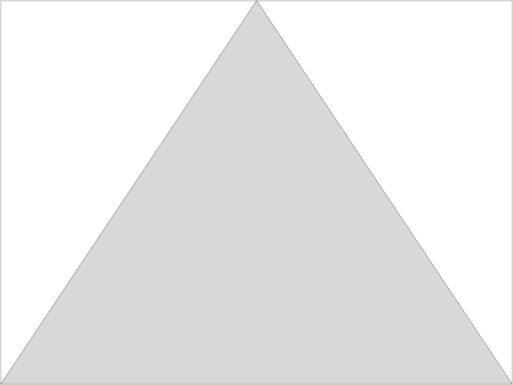 Draw a square 8⅞" width and height 6¾". Mark the centre of square at the top and draw a line from the bottom to the top as in the template 1 diagram. (Do not add a ¼" seam)

Template 2 with this one you will have a left and right.
This time your will have a rectangles 4⅜" width and 7⅛" height.
. (Do not add a ¼" seam)
 Right template

 Left template

Cutting
From fabric 1 cut
3 from template 1
1 from template 2
1 from template 3
From fabric 2 cut
2 x 1½" x 41½"
2 x 1½" x 8½"
From fabric 3 cut
4 from template 1
From fabric 4 cut
2 x 1½" x 39½" (border 2)
2 x 1½" x 6½"
From fabric
2 x 3" x 6½" (end border)

Lay out the fabric pieces

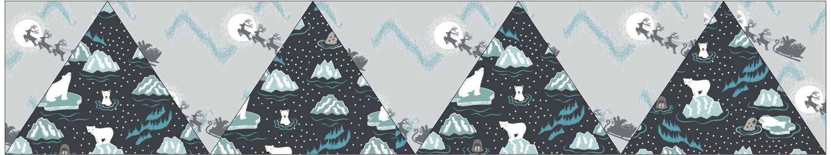

Sew the row together.

Now sew the outer border at the end of the block.

Sew border 2 next sides, top and bottom.

Add the last border sides, top and bottom

Quilting
Sandwich the runner top, wadding and backing together.
Quilt by hand or machine as desired.
Trim backing and wadding to size.
Binding
Use your favourite method of fabrics 2 to bind the quilt.

