Harbour Side
Lewis & Irene
Design and made by Sally Ablett
16" x 16"

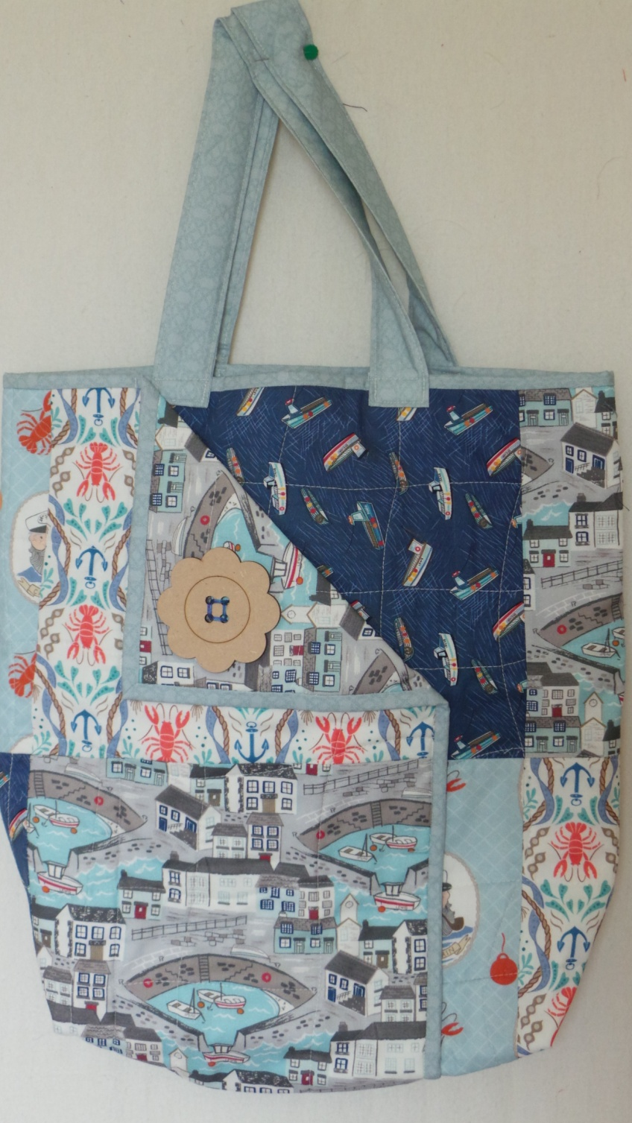

REQUIREMENTS
Fabrics from the Harbour side collection:
Five assorted fat ¼ of Lewis and Iren Harbour Side
20" of wadding
A button to decorate.
Sew with a ¼" seam allowances, unless stated.
Cutting
Select four fat quarters for the body of the bag.
From each one cut
4 x 9½" wide and 10½" high
Binding and handles from the last fat quarter
4 x 1½" x 21" (binding)
2 x 3½" x 21"
From wadding
2 x 1¼" x 20"
1 x bag when made up.
Arrange eight rectangles in two rows of four.

Sew each row together and press. Repeat for the lining of the bag. You will have two pieced panels.
Cut out a piece of wadding to the size of the bag panel.
Sandwich the outer panel, wadding and lining panel together. Quilt by hand or machine with a design of your choice.
Join the binding strips together end to end, into one long piece. Stitch to bag using a ¼" seam. Stitch the binding to the left side, top edge and right side on the front of the bag panel. Fold the binding over and hand stitch into place
On the front, mark 8½" in from the left edge of the bag with a pin. Turn the panel over so the lining is uppermost. Fold the left side over the right as far as the 8½" mark. Pin the overlap in place to make a tube.
Sew down the left hand side of the overlap. You may find it easier to turn the bag inside out and use the edge of the binding as a guide.
On the right hand side of overlap, mark 7½" down from the top. Stitch from this point down to the bottom. Remove the pins and fold the corner back to make a flap. Sew the button into place, leaving the pocket open.
With the pocket at the centre front of the bag, place pins to mark the centre point at the top and bottom of bag. Turn the bag inside out and match the centre points. Stitch the base of bag, then zigzag or overcast the raw edge to neaten.
Create a flat base to your bag by mitring the corners and stitch. Trim away the excess, neaten the raw edges and turn through to the right side.
To make the handles, turn in ¼" down each long edge and at the short ends, press. Fold in half lengthways and press. Place a wadding strip into the fold. Stitch about a ¼" in on both sides to secure. Pin the handles on the outside of the bag, equally spaced. Made sure they aren`t twisted then sew into place.

