A Walk in the Glen 3
Lewis & Irene
Designed and made by Sally Ablett
Size 47" x 57"
Block size 10" square
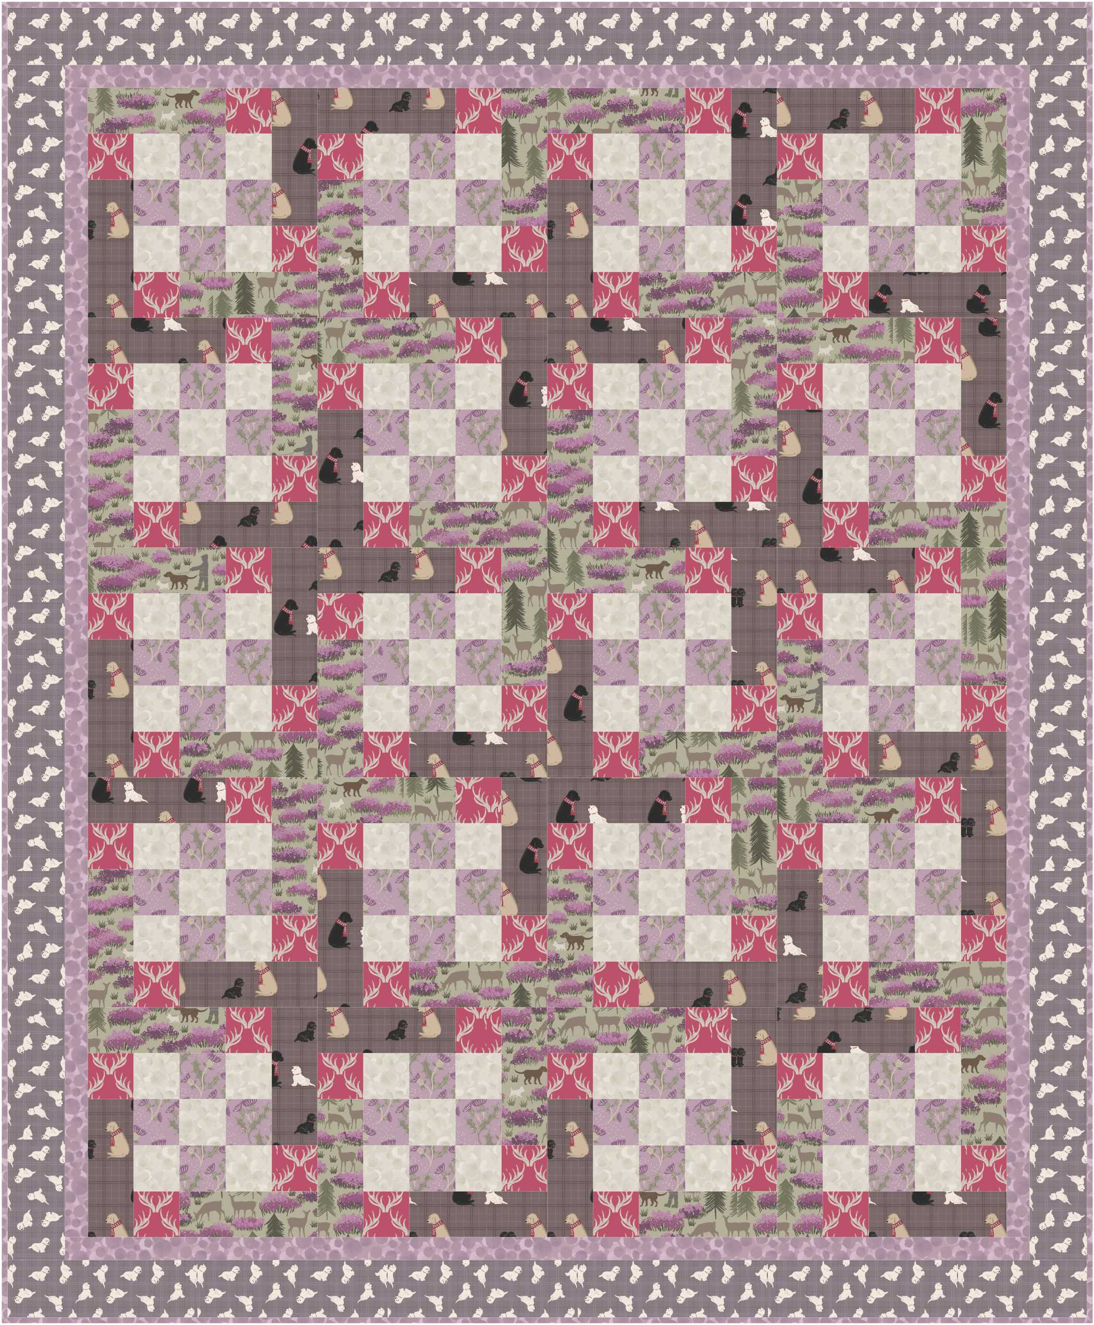

REQUIREMENTS
Fabrics from the A Walk in the Glen collection:
- 40cm A89.5 – Thistle on lilac (fabric 1)
- 50cm A156.2 – A Walk in the Glen on field green (fabric 2)
- 40cm A157.2 – Antlers on rose (fabric 3)
- 50cm A158.2 – Dogs on soft brown check (fabric 4)
- 50cm A59.2 – Tumbled Westies on warm check (fabric 5)
- 60cm BB87 – Heather Bumbleberries (fabric 6)
- 50cm BB41 – Off white Bumbleberries (fabric 7)
- 51" x 61" Wadding
- 51" x 61" backing

CUTTING
Cut across width of fabric. Note some strips are cut along length of fabric, parallel to selvedge.

1. From fabric 1 cut:
five, 2½" x WOF strips sub cut into:
eighty, 2½" squares.
2. From fabric 2 cut:
seven, 2½" strips cut along length of fabric sub cut into:
twenty, 2½" x 6½" horizontal rectangles,
seven, 2½" strips cut across remainder of WOF sub cut into:
twenty, 2½" x 6½" vertical rectangles.
3. From fabric 3 cut:
five, 2½" x WOF strips sub cut into:
eighty, 2½" squares.
4. From fabric 4 cut:
seven, 2½" strips cut along length of fabric sub cut into:
twenty, 2½" x 6½" horizontal rectangles,
seven, 2½" strips cut across remainder of WOF sub cut into:
twenty, 2½" x 6½" vertical rectangles.
5. From fabric 5 cut:
five, 3" x WOF strips – outer border.
6. From fabric 6 cut:
five, 1½" x WOF strips – inner border,
five, 2½" x WOF strips – binding.
7. From fabric 7 cut:
seven, 2½" x WOF strips sub cut into:
one hundred, 2½" squares.

PIECING
Use ¼" seam allowance throughout. Press all seams open unless otherwise noted.

1a. Take four, 2½" fabric 1 squares and five, 2½" fabric 7 squares and arranges squares in three rows of three squares, alternating fabrics.
b. Join squares together in rows. Press seams towards fabric 1 squares.
c. Join rows together to make Nine Patch unit which should measure 6½" square.

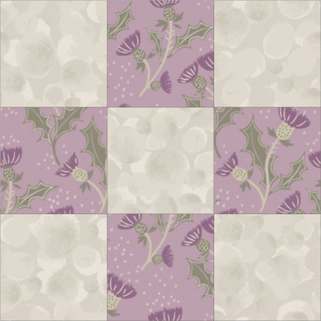

2a. Take two, 2½" x 6½" fabric 2 horizontal rectangles and two, 2½" x 6½" fabric 4 vertical rectangles together with four, 2½" fabric 3 squares and arrange pieces around Nine Patch unit.
b. Join fabric 3 squares to ends of rectangles.
3. Assemble block by joining pieced strips to Nine Patch block using partial seams as necessary.

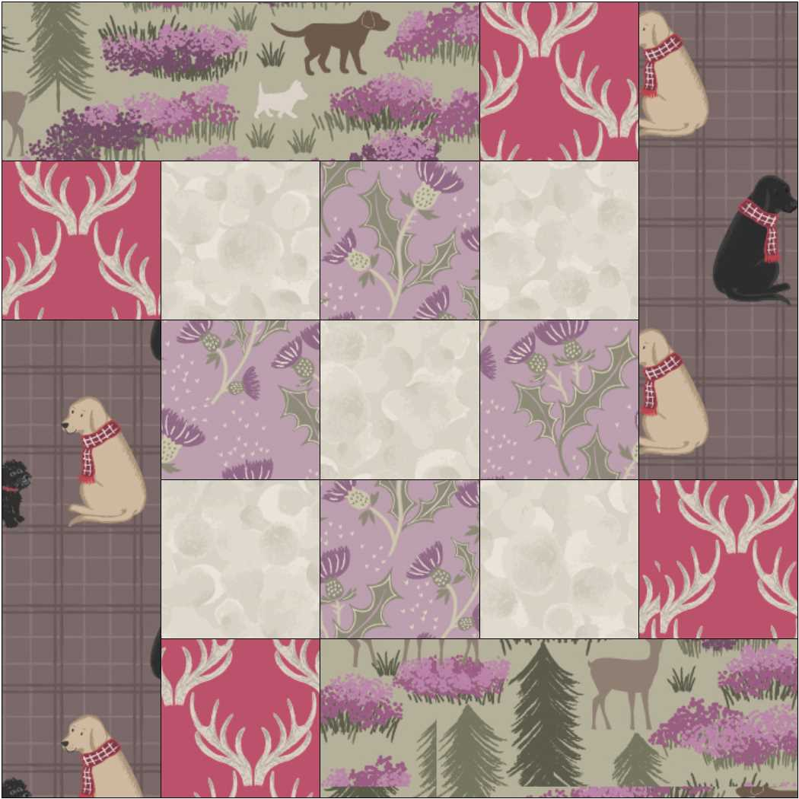

4. Make ten of Block One in total which should measure 10½" square.
5. Make ten of Block Two in similar manner with remaining pieces.

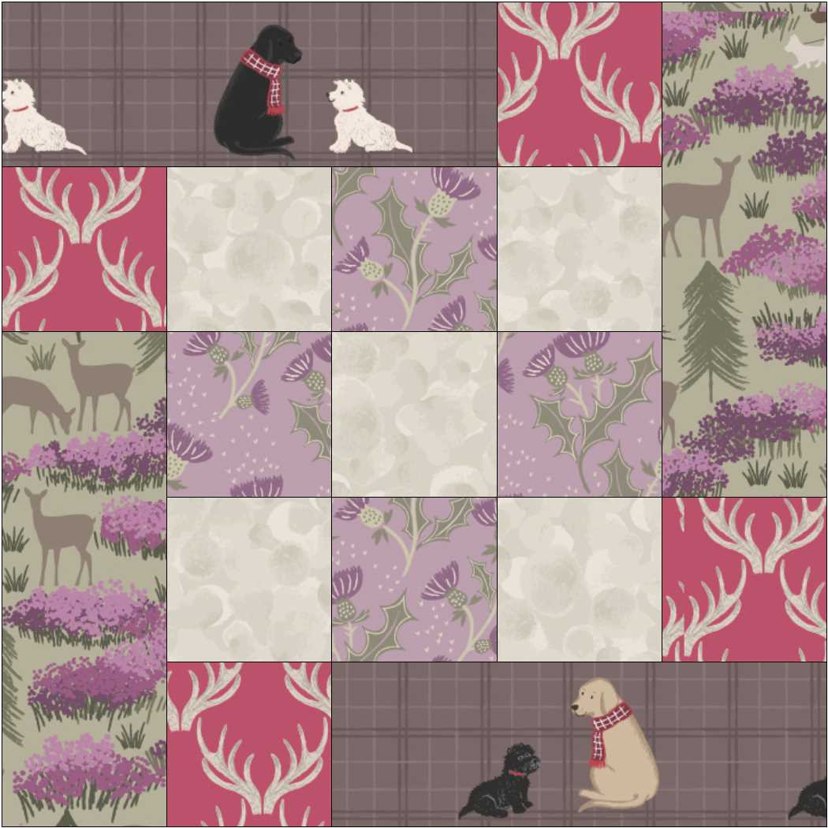

ASSEMBLY

1a. Arrange blocks into five rows of four blocks, alternating blocks.
b. Join blocks together in rows. Press seams for alternate rows in opposite directions.
c. Join rows together to complete quilt centre.
2a. Take three, 1½" fabric 6 strips and join strips end to end.
b. Sub cut joined strips into two, 1½" x 50½" strips.
c. Join strips to opposite sides of quilt.
d. Add remaining strips to top and bottom edges to complete inner border.
3. Make and add outer border in same way by joining 3" fabric 5 strips together end to end and sub cutting to make:
two, 3" x 52½" side borders and
two, 3" x 47½" top and bottom borders.

COMPLETION

1. Sandwich quilt top, wadding and backing. Pin or baste layers.
2. Quilt as desired.
3. Double bind edges with 2½" fabric 6 strips.

© Lewis & Irene 2016

