2 Bunny Garden
Lewis & Irene
Designed and made by Sally Ablett

Size: 52" x 52"
Block size 9½" x 9½"

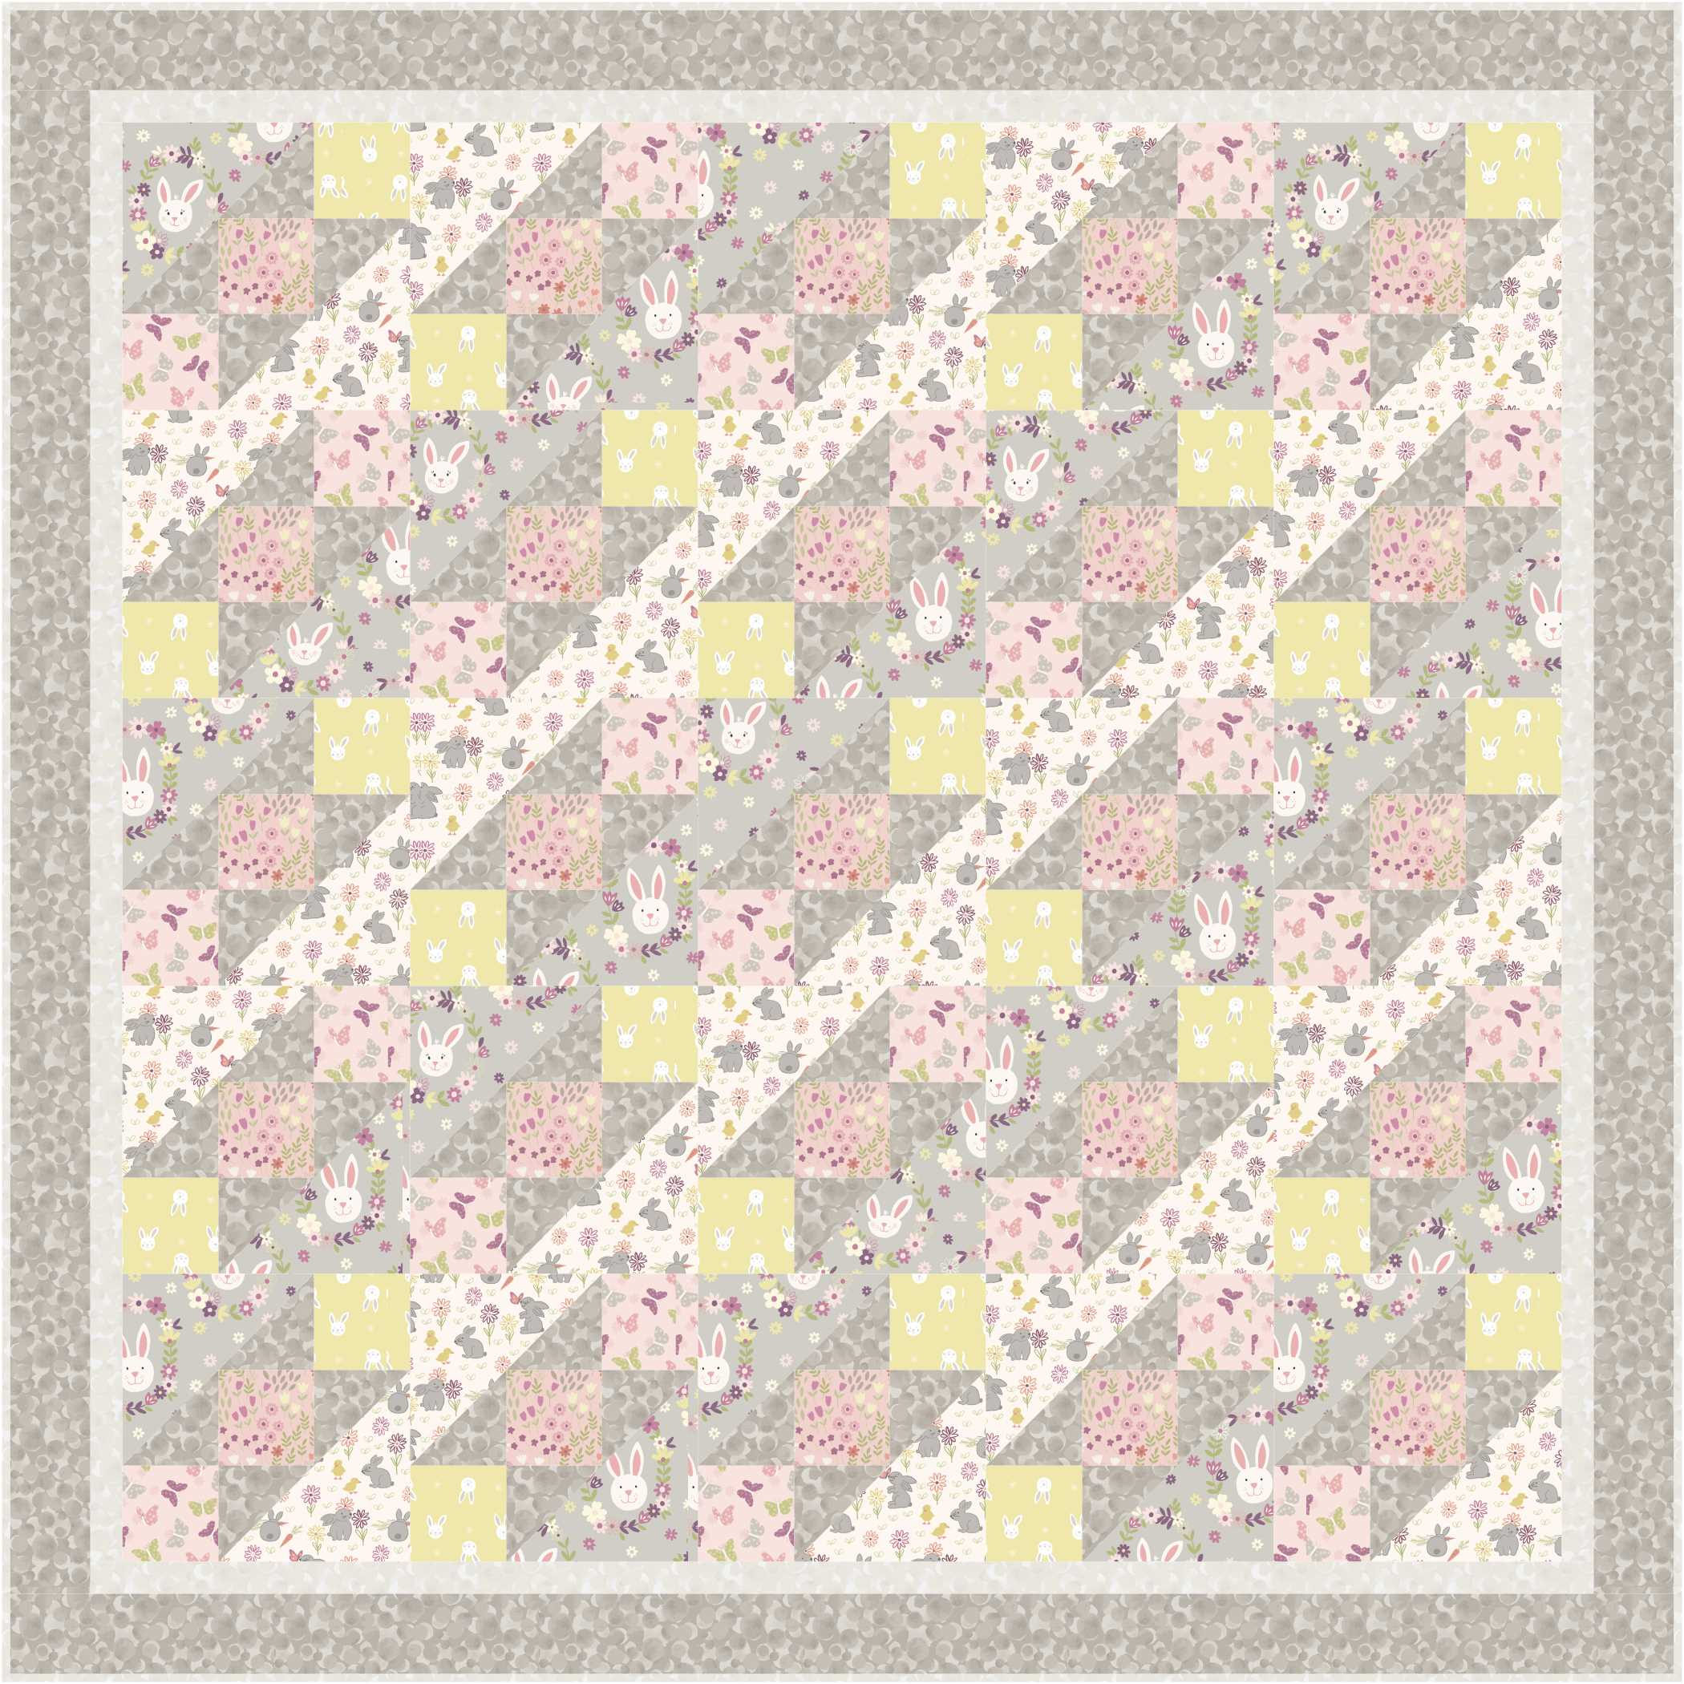

Main diagram

REQUIREMENTS
Fabrics from the Bunny Garden collection:
- A146.2 – Bunny wreath on light grey - ⅝yd - 60cm
- A147.2 – Pretty flowers on pink - ⅜yd - 30cm
- A148.1 – Bunny adventure on white - ⅝yd - 60cm
- A149.2 – Butterflies on pink - ⅜yd – 30cm
- A150.3 – Leo bunny on yellow - ⅜yd – 30cm
- BB66 – spring yellow - ⅝yd – 60cm
- BB68 – spring green - 1¼yd – 1¼mtr
Wadding and backing 56" x 56"

Use ¼" seam allowance throughout. Press all seams open unless otherwise noted.

Cutting
From fabric 1 cut
12 x 6⅞" x 6⅞" cut in half diagonally once (cut from bottom left to top right)
From fabric 2 cut
25 x 3½" x 3½"
From fabric 3 cut
12 x 6⅞" x 6⅞" cut in half diagonally once (cut from bottom left to top right)
From fabric 4 cut
25 x 3½" x 3½"
From fabric 5 cut
25 x 3½" x 3½"
From fabric 6 cut
2 x 1½" x 45½" (join fabric)
2 x 1½" x 47½" (join fabric)
From fabric 7 cut
2 x 3" x 47½" (join fabric)
2 x 3" x 52½" (join fabric)
50 x 3⅞" x 3⅞" cut in half diagonally once
Making up block
Lay out all the fabric pieces for each of the blocks.
On block 1 you will have fabric 1 in the top left hand corner with fabric 3 in the bottom right corner, and on block 2 fabric 3 will be in the top left and fabric 1 in the bottom right corner.
Start by sewing in rows the top triangle of fabric 7 to the square of fabric 5. Press your seam to the right.
Next sew the triangle of fabric 7 to the square of fabric 2 and then the triangle of fabric 7 together. This time press your seam to the left.
Then sew the last square of fabric 4 to the triangle of fabric 7. Press again to the right this will help when you sew rows together.
Sew the rows together and then add the lager triangles of fabric 1and fabric 3 to each side of the panel to make the block.
Sewing 25 blocks in total.
Making up quilt
Lay out all the blocks as in the main diagram
Sew the rows together pressing the seams of each row in the opposite way each time. This will help when you sew the rows together.
Sew the rows together
When you have all your blocks sewn together add the inner borders of fabric 6.
Sew the sides and then the top and bottom.
Now add the outer border again sides and then the top and bottom of fabric 7
Sandwich together the quilt top, wadding and backing.
Quilt by hand or machine as desired.
Binding
Use your favourite method from fabric 7 to bind the quilt
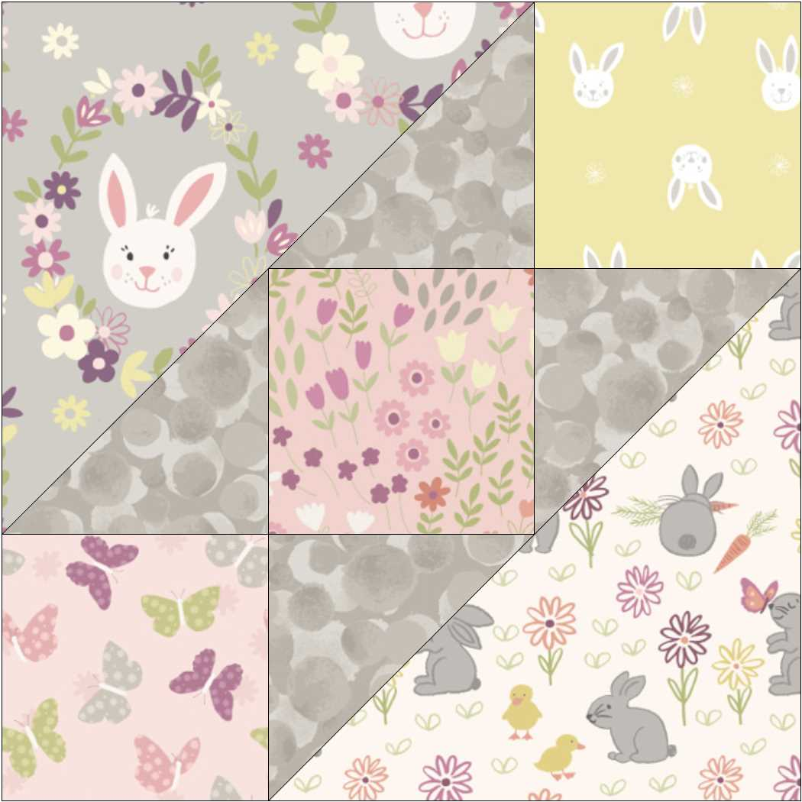
Block 1

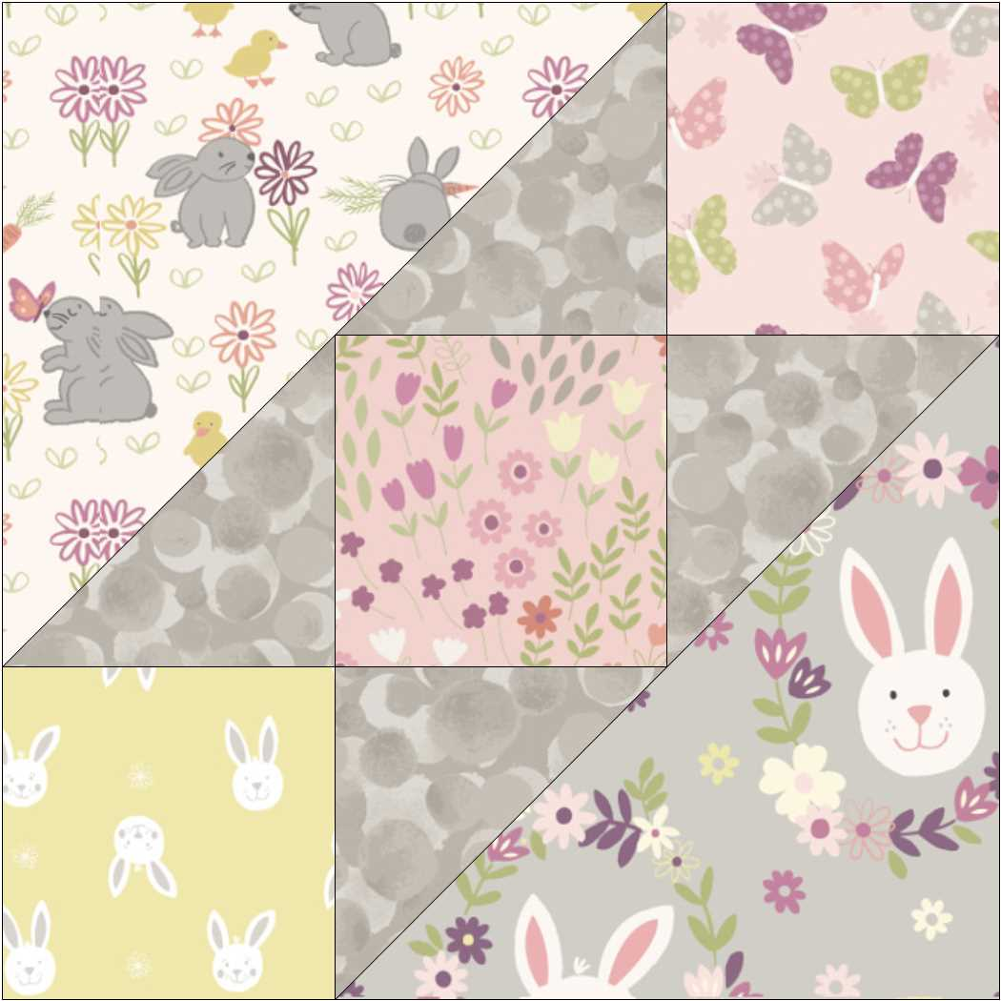
Block 2

