Home Sweet Home
Lewis & Irene
Design and made by Sally Ablett
Size 52" x 52"
REQUIREMENTS
Fabrics from the home sweet home collection:
Wadding from the warm company

- A96.1 – feather for your nest on blue - fat¼
- A97.2 – blue & green flower garden on cream - fat¼
- A98.2 – daisy chains on Cornish cream - fat¼
- A99.3 – song bird on folksy green - fat¼
- A100.1 – happiness is homemade on navy - fat¼
- A100.3 – happiness is homemade on folksy green - fat¼
- BB40 – off white – 2mtr
- BB45 – aquamarine - fat¼
- BB49 – ink - long¼
- BB50 – retro red - fat¼
Wadding and backing 56" x 56"
All measurements include ¼" seam allowances; press each seam as you go.
Cutting
From each of the fabrics 1, 2, 3, 4, 5, 6, 8 and 10 cut
1 x 8⅞" x 8⅞" cut in half diagonally once
2 x 2½" x 11½"
From fabric 9 cut
2 x 1½" x 32½"(inner border)
2 x 1½" x 44½ (you will have to join your fabric for the length) Inner border
From fabric 7 cut
2 x 5½" x 34½" (middle border)
2 x 5½" x 44½" (middle border)
2 x 2½" x 48½"(outer border)
2 x 2½" x 52½"(outer border)
4 x 2½" x 2½" (corners on middle border)
4 x 8½" x 8½"
Making up
Lay out the pieces for centre of block 1
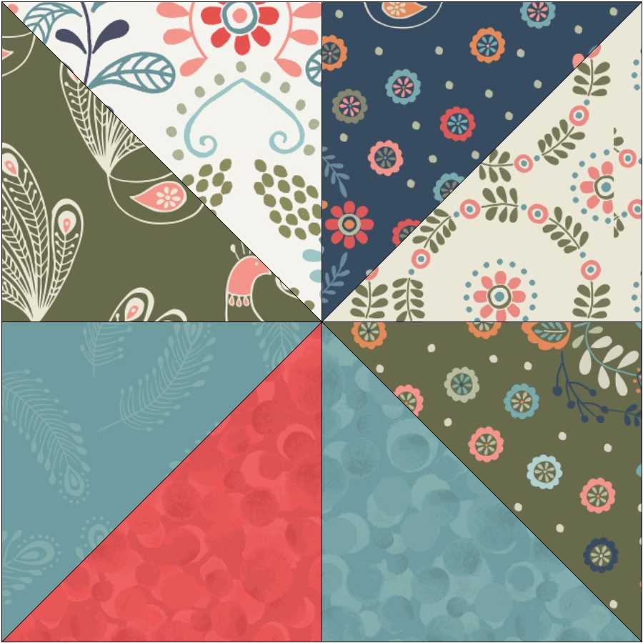
Sew the small triangles together and then sew them together to make a square.
Next sew the squares together. Sew your squares in rows and then sew the rows together to make the block.
Make up your four sets of flying geese blocks.
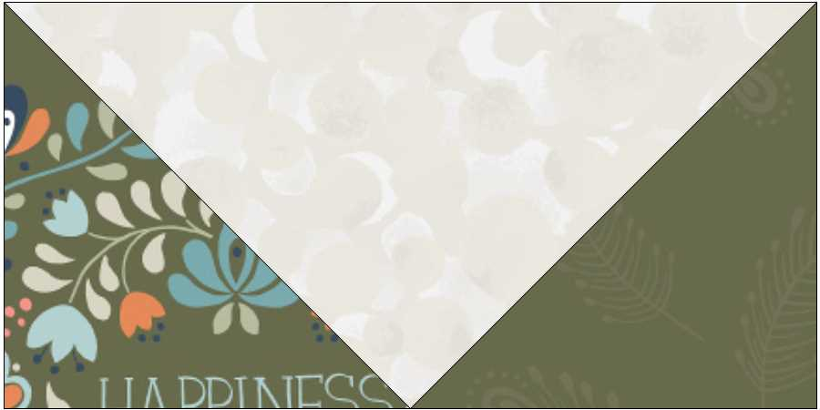
Sew small triangles to the large triangles.
Lay out all the pieces for the block and sew them in rows. Then sew the rows together.
Add the inner border sides and then top and bottom.
Now sew the next border sides and then top and bottom.
Make up the next border sew your strips as in main photo. Sew the sides and then add the squares to each end of the last two strips. Sew this to the quilt.
Add the last border sides and then top and bottom.
Sandwich the quilt together top, wadding and backing. Quilt by hand or machine.
Trim off the wadding and backing, Sew the binding using your left over pieces of fabric.

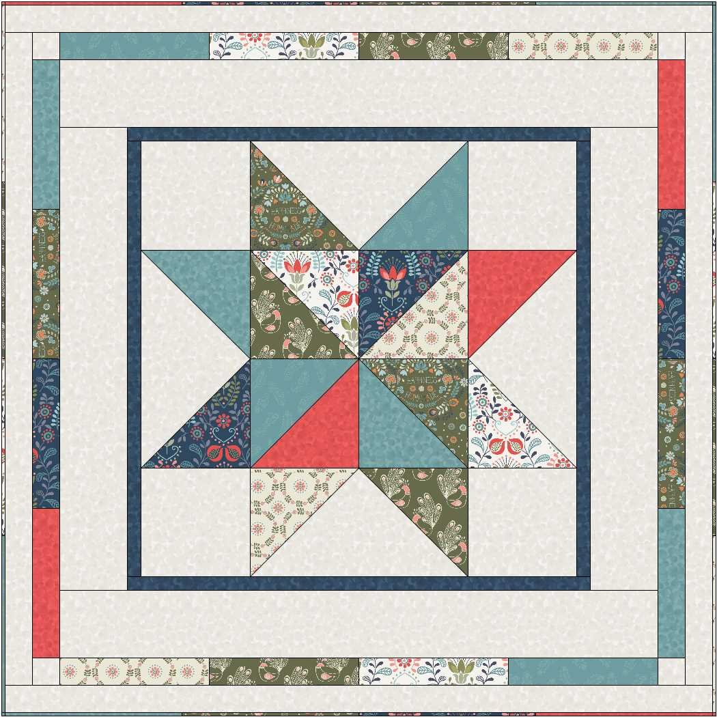
Main photo

