Country Life
Lewis & Irene
Design and made by Sally Ablett
Runner size 17" x 53"
Mat side 16" x 16"
REQUIREMENTS
Fabrics from the country life collection:
- A90.2 – little hens on natural - long¼
- A91.2 – friendly pheasant on grey - long¼
- A92.1 – country life on grey - long¼
- A94.2 – woolly sheep on natural - long¼
- A95.1 – cow parsley & bee on country blue - long¼
- BB41 – light linel - ½mtr
- BB40 – off white - ½mtr
Wadding and backing 1mtr
All measurements include ¼" seam allowances; press each seam as you go.
Cutting for runner
From fabric 1 cut
16 x 2⅝" x 5⅛" cut a 45º angle from top left corner
From fabric 2 cut
4 x 5⅜" x 5⅜" cut in half diagonally once
From fabric 3 cut
4 x 5⅜" x 5⅜" cut in half diagonally once
From fabric 4 cut
2 x 2" x 17½" outer border
2 x 2" x 50½" outer border
From fabric 5 cut
4 x 4¼" x 4¼" cut in half diagonally twice
From fabric6 cut
4 x 7¼" x 7¼" cut in half diagonally twice
16 x 2" x 6⅞" cut a 45º angle from top left corner
From fabric 7 cut
2 x 1½" x 14½" inner border
2 x 1½" x 50½" inner border
Making up
Lay out your fabric pieces for each block.
The block is made up of eight segments, sewing each one into a triangle.
Sew two triangles together to make a square and then the squares together to make the block. You will made 4 in total.
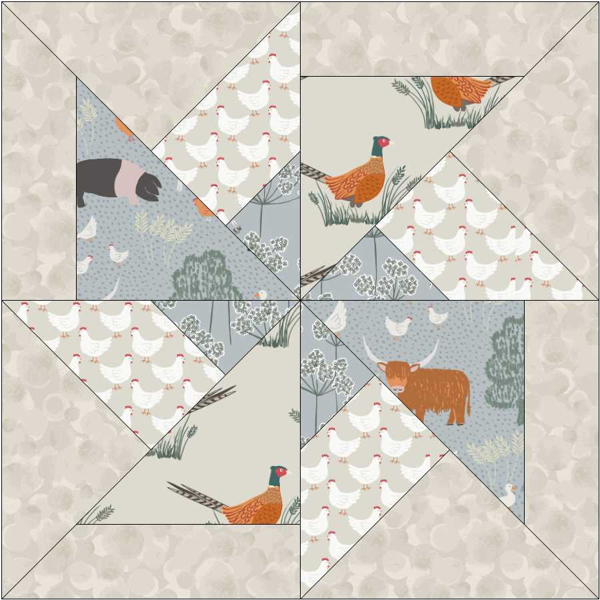 Block for runner

Join the four blocks together.
Next add the inner border sides and then top and bottom.
Now add the outer border sides and then top and bottom.
Sandwich runner top, wadding and backing together and quilt by hand or sewing machine.
Add binding using fabric 7.
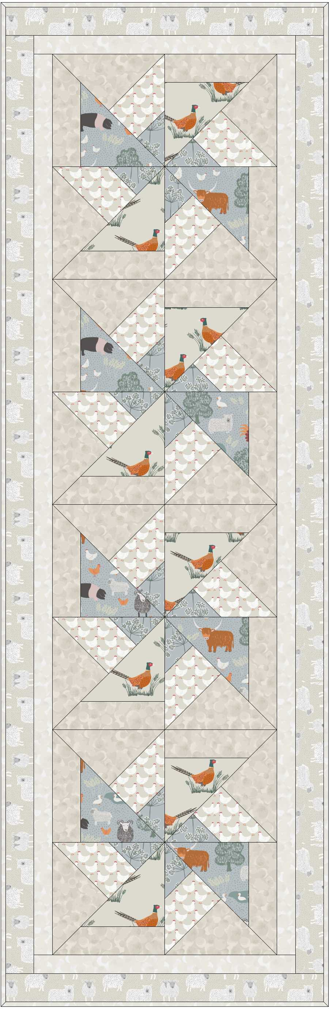
Runner

Cutting for mats
From fabric 1 cut
16 x 2⅝" x 5⅛" cut a 45º angle from top left corner
From fabric 2 cut
4 x 5⅜" x 5⅜" cut in half diagonally once
From fabric 3 cut
4 x 5⅜" x 5⅜" cut in half diagonally once
From fabric 4 cut
2 x 1½" x 14½" outer border
2 x 1½" x 16½" outer border
From fabric 5 cut
4 x 4¼" x 4¼" cut in half diagonally twice
From fabric6 cut
4 x 7¼" x 7¼" cut in half diagonally twice
16 x 2" x 6⅞" cut a 45º angle from top left corner
From fabric 7 cut
2 x 1½" x 12½" inner border
2 x 1½" x 14½" inner border

Making up mats
The mats are made up as runner blocks and the borders are the same too.

