A Walk in Glen
Lewis & Irene
Made by Sally Ablett
Size 20" x 20" (6" high)
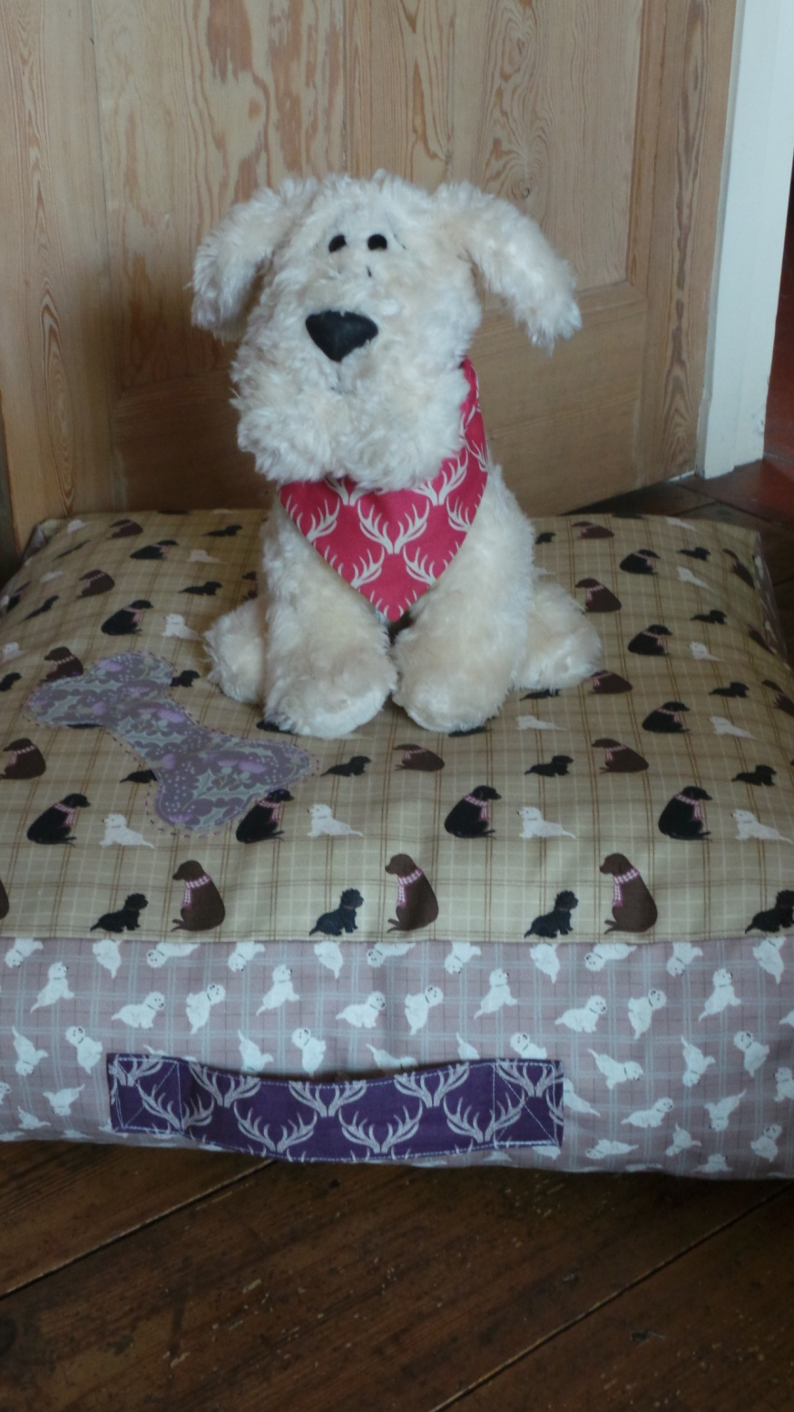

REQUIREMENTS
Fabrics from the A Walk in the Glen collection:

- A158.1 - Dogs on natural check - ⅝yd - 60cm
- A159.2 - tumbled westies on warm check - ⅜yd - 30cm
- A157.3 - antlers on deep blackberry fat¼
- Lining fabric 1¼yds - 1¼mtr
Stuffing
Use ¼" seam allowance throughout. Press all seams open unless otherwise noted.
Cutting
From fabric 1 cut
2 x 20½" x 20½"
From fabric 2 cut
4 x 6½" x 20½"
From fabric 3 cut
1 x 4½" x 9½"
From fabric 4 cut
2 x 20½" x 20½"
4 x 6½" x 20½"

Making up the bed
Base the outer fabrics pieces of bed to the lining pieces. You may like to appliqué a bone to the top of your bed. Stitch the outer fabrics and lining fabric together.
Handle
Turn in a ¼" on all sides, press into place. Now fold in half and stitch down. Add this to the bed on the side; stitch the handle at each end only into place.

Sewing bed together
Take the four sides and mark a ¼" in from each end on the short sides. Sew together the sides from the mark dot and finish on the dot. This means you will have a little ¼" flap at the start and end of your seam.

Now sew the top and bottom panels to the side’s piece. Align one edge and pin the two pieces together, sew by starting and ending the seam a ¼". It may help to mark a ¼" dot again on your fabric pieces. Sew all the seams, but in the middle on one leave an opening for turning and stuffing about 5".

Turn to the right side and stuff well. Sew up the opening.

