Autumn Fields
Lewis & Irene
Design and made by Sally Ablett
Size 51" x 54"
REQUIREMENTS
Fabrics from the autumn field collection:
Wadding from the warm company

- A111.3 - barley mouse on country green - fat¼
- A112.1 - dark berries - fat¼
- A113.3 - acorns & leaves - fat¼
- A114.3 - field mouse on country green - fat¼
- A115.1 - harvest mouse nests on grey fat¼
- BB42 - vellum - 1mtr
- BB54 - harvest brown - 70cm
- BB56 – blackberry - 60cm
Wadding and backing fabric 55" x 58"
All measurements include ¼" seam allowances; press each seam as you go.
Cutting
From each of the fabrics cut
6 x 5½" x 5½"
From fabric 6 cut
2 x 2½" x 44½" (sides, you will have to join your fabric to get the length)
2 x 2½" x 46½" (top & bottom again you will have to join your fabric)
30 x 3" x 5½" (sashing)
From fabric 7 cut
5 x 2½" x 38" (sashing)
2 x 2½" x 40½" (sides)
2 x 2½" x 42" (top & bottom)

From fabric 8 cut
2 x 3½" x 48½" (sides, you will have to join your fabric)
2 x 3½" x 52" (top & bottom, you will have to join your fabric)
Lay out your fabric pieces as in the main diagram.
Sew the squares to the sashing pieces in rows.

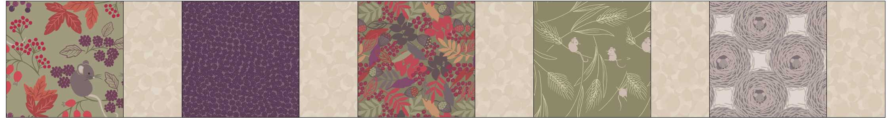
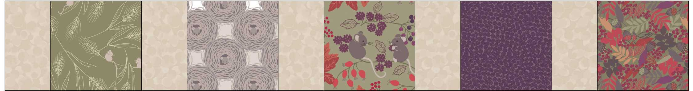
Row 1 and row 2 you will keep sewing row 1 and row2 until you have 6 rows.
Sew the sashing in between each row.
Add your 3 borders sides and then top and bottom.
Sandwich the quilt together top, wadding and backing. Quilt by hand or machine.
Trim off the wadding and backing, Sew the binding using your left over pieces of fabric.
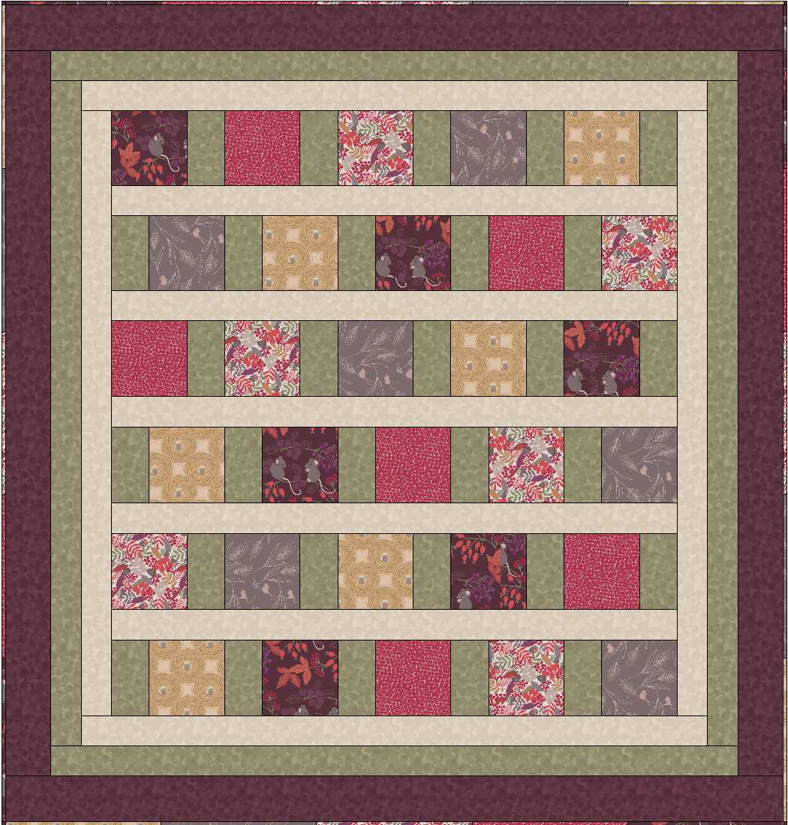
Main diagram

